US Politics & Polarization

**The Problem**

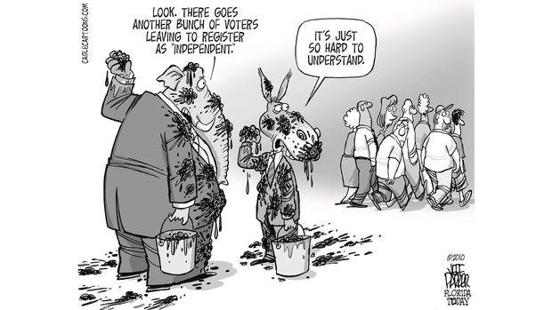Public perception is that US politics is more polarized than ever. Republicans are drifting further right, Democrats are drifting more left, and compromise is becoming rarer. However, is this shift truly reflected in the data? How could we quantify this and show it visually?

**The Data**

We used two main data sources for our analysis. The first is an analysis done by that indexes the “leftness” or “rightness” of congress members going all the way to 1789. Our other datasource was the results of the 2008, 2012, and 2016 elections by congressional districts.

**Congressional Ideology**

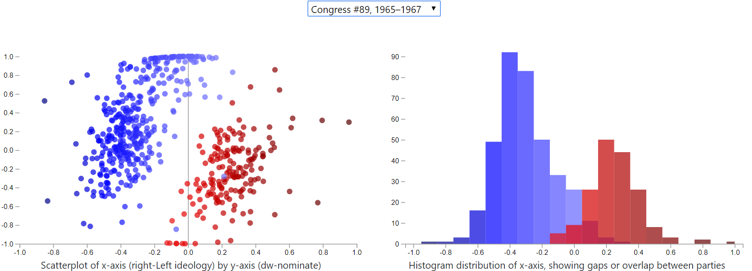

The scatterplot and histogram above represent the political ideologies of the 1965 – 1967 congress. On graphs, A -1 represents and extremely leftist ideology. Conversely, a 1 is an extremely conservative ideology. We can see that there are some congressmen and women that cross the other side of 0 from their party. Likewise, we can see a purple overlap that represents the political moderates.

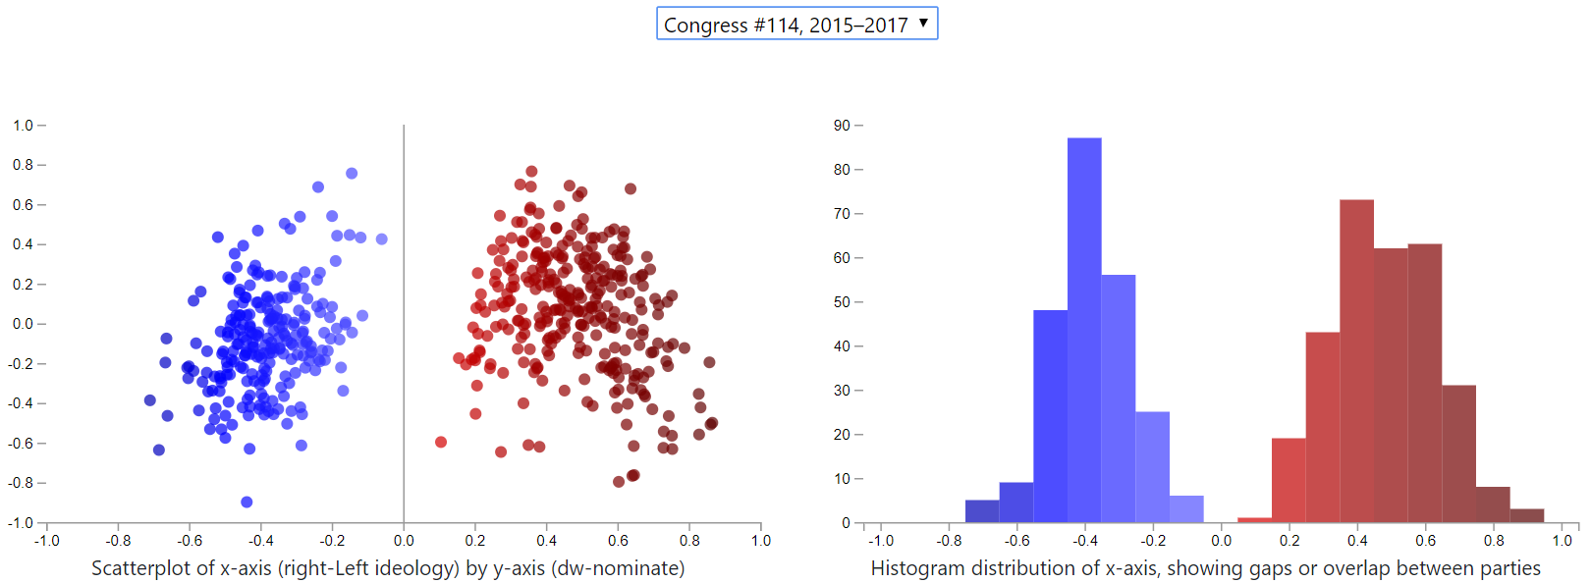

When we update the chart to show the 2015 – 2017 congress, we see that middle ground disappear. The scatter plots are in tight bunches far from 0. The purple overlap in the histogram completely disappeared.

To show this trend over time, we used the ChartsJS module to plot the average ideology over time

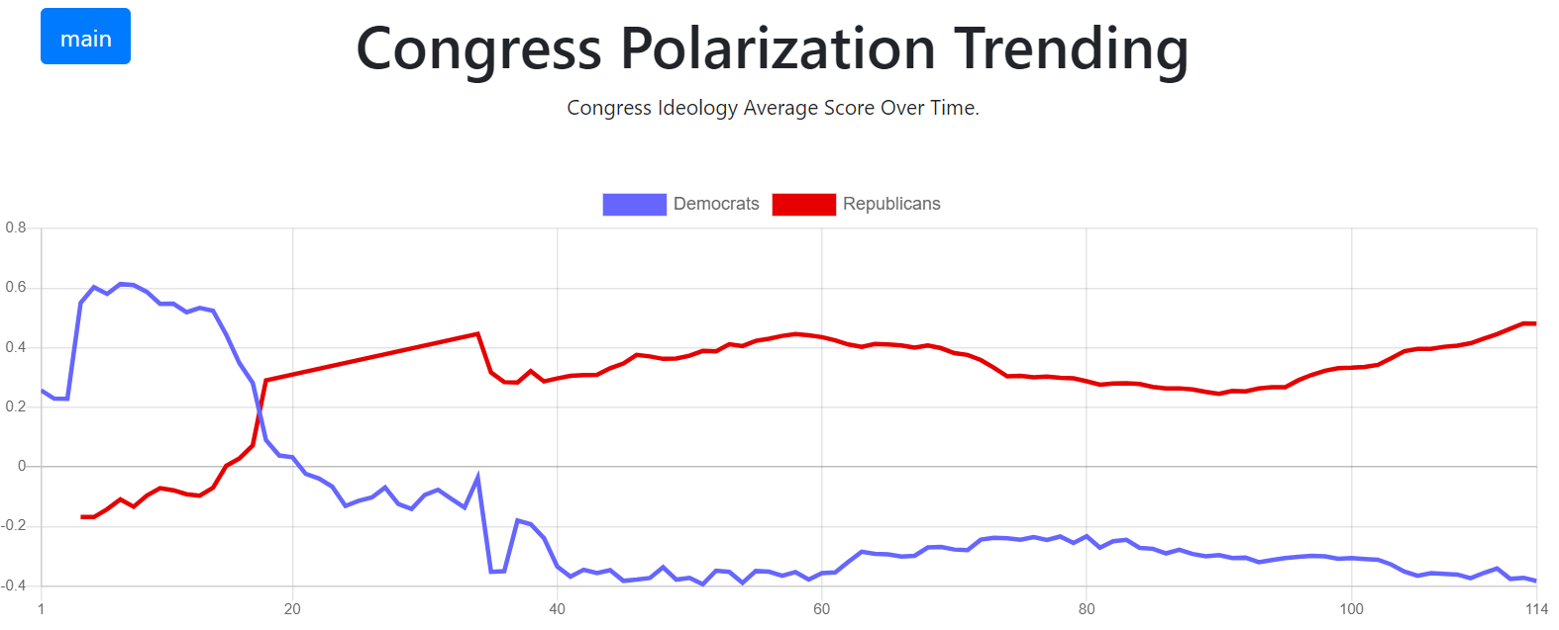

We can see that after a mild convergence after the 80th congress, the parties sharply move apart.

**Election Map**

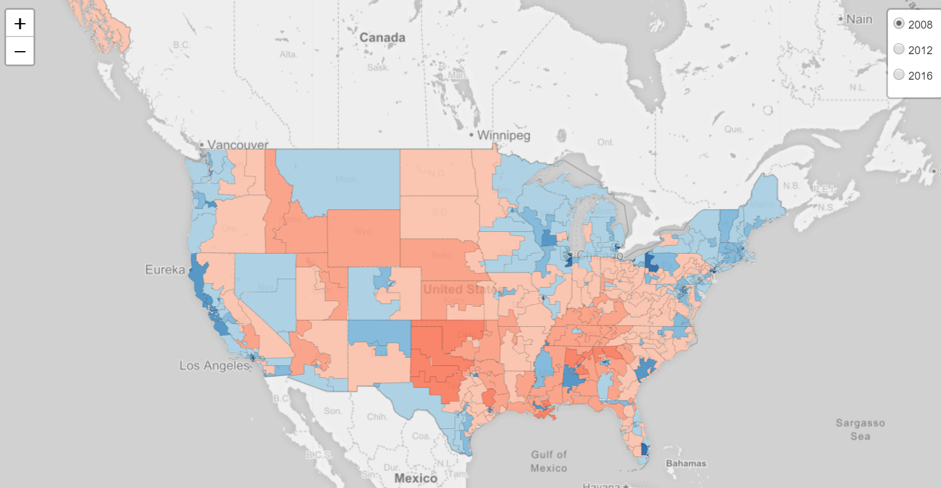

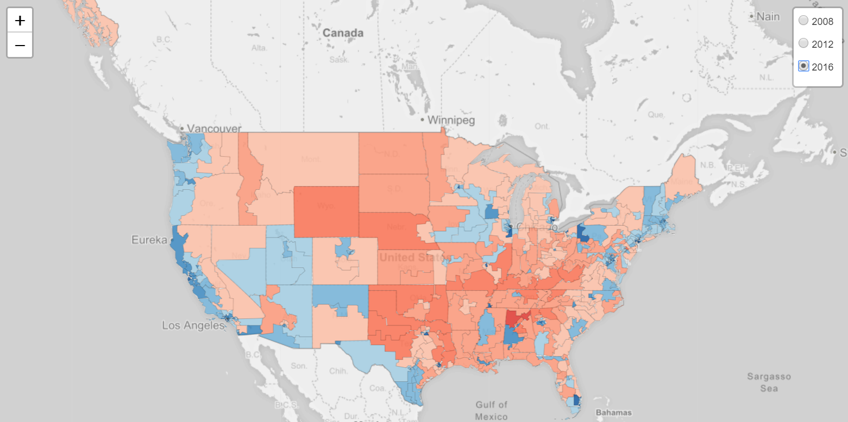

We also see this polarization in the election results. When we compare the 2008 an 2016 elections, we can see the intensification of the colors in the political strongholds for each party; The heartland for Republicans and the west coast for Democrats